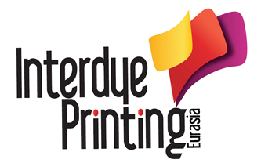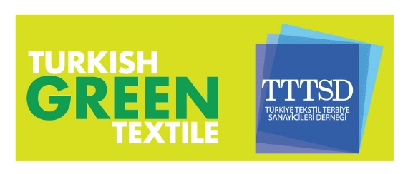

07.03.2016

Interdye & Printing Eurasia will open its doors to visitors on Thursday March 10th for the 3rd time ...
Pretreatment, Printing, Digital Printing, Finishing, Coating and Denim Industries will come together with Printing Inks, Pigments, Main and Auxiliary Textile Chemicals sector professionals in Interdye & Printing Eurasia which will be held between 10 - 12 March 2016 in Istanbul Expo Center…
Dyestuff, Printing Inks, Pigments, Chemicals, Printing and Dyeing Technologies Exhibition “Interdye & Printing Eurasia 2016 which will be held for the 3rd time in cooperation with Turkish Textile Dyeing and Finishing Industrialists Association (TTTSD) will bring together many local and foreign companies between 10-12 March 2016.

Industry Leaders take their places in Interdye & Printing Eurasia
Archroma, Bozetto Kimya, Cosmo Kimya, Denge Kimya, Dystar, Everlight, Huntsman, Pürsan, Inter Royal, İlteks, Tekay, Setaş and many other sector leaders take their places in Interdye & Printing Eurasia 2016.

Interdye & Printing Eurasia 2014 Facts & Figures
2nd Dyestuff, Printing Inks, Pigments, Printing and Dyeing Technologies Exhibition: Interdye & Printing Eurasia 2014 which was organized in cooperation with Turkish Textile Dyeing and Finishing Industrialists Association (TTTSD) brought together 65 international exhibitors from 15 countries, in total 96 companies and company representatives.
2504 industry professionals visited the exhibition for 3 days. 217 of the total visitors were international industry professionals from 31 countries.

We invite all textile sector leaders to Interdye & Printing Eurasia 2016
Biennially organized and become more bigger for every year ”Interdye & Printing Eurasia“ will host the sector professionals in Istanbul Expo Center’s Hall 9.
The exhibition which can be visited as free of charge for visitors and provide its exhibitors to make presentations on their new products and technologies through visitors at Workshop Area.
___________________________________________________________________________

Interdye & Printing Eurasia 2016 Opening Programme

Openning Time: 10th of March 2016 at 11.00 a.m
Venue: Hall 9 - 10 and Foyer
Organization:
Opening Speech
Ribbon Cutting Ceremony
Visiting the Stands

Please visit www.interdyeprinting.com for Detailed Informations and Free Online Invitation Letter.

